Reflection Paper
[Author]
[Institution]
TABLE OF CONTENTS
Abstract 1
Reflective Report 2
1) Summary 2
2) RMP project 4
REFERENCES 6

TABLE OF FIGURES
Figure 1: Risk management 2

Abstract
Risk management is the organizational policy for optimizing the investment and overcome the possibilities of the failure in the project. The report has undergone analysis of theoretical knowledge about risk management. The current study has reflected that risk management plays important role in reducing unnecessary cost of the organization in coming future. The study has even indicated the possible risks involved in the projects and strategies that can be used to overcome various risk. At the time of completing this investigation I have gained lots of new knowledge about critical path analysis, risk register and other project management tools which can help in managing project with lowest risk. Another segment of this report has been focused on RMP project which is based on construction project. In these types of project there are number of risks such as technical, operational, financial and environmental. So, managing these types of risks the current study has developed a suitable risk management plan.

Reflective Report

1) Summary
Risk management is an essential approach for managing the factors and elements that could affect the feasibility and objectives of a project. Risk can come from various sources that inculcate the uncertainty in the financial market, lack of using the standard approaches in the planning and handling of the operations. There are some natural causes also have the direct impact on the risk conditions for a project that needs to be considered by the project manager. Risk management is the organizational policy for optimizing the investment and overcome the possibilities of the failure in the project. The term risk refers to failure in the meeting of the objectives of the specified project. There are different types of approaches have been used for managing the risk as well having the prior knowledge about the risk in the particular project to meet the goals more convincing manners (Walker, 2015).
By the study about this topic, I have gained the understanding of the different aspects of risk management as a manager and team plays the critical role in the planning and management of operations to meet the objectives of the project. The research will help me to evaluate the possible risks involved in the projects and strategies that can be used to overcome the risk related to cost, scope and scheduling of the project.
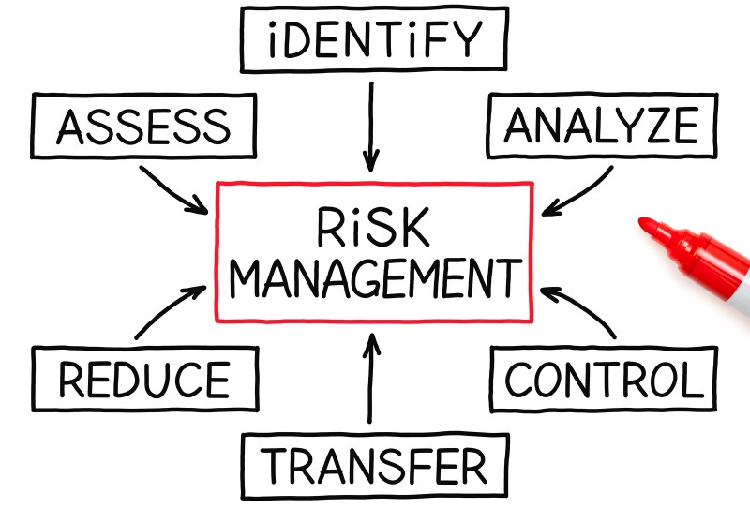
Figure 1: Risk management
(Source: https://onlinemarketinghits.com/what-is-risk-management/)
According to analysis, the major goal of the risk management audit is to improve the effectiveness of the project by minimizing the cost of operation and reducing the possibility of rework in the future. To be the successful delivery of a project requires the consideration risk management process according to the specification of a particular project (Hwang.et al. 2014). From the research, I have gained the knowledge about the process that is used for identifying the risk, planning of the activities and minimization of consequences of adverse events. The risk management process involves the consideration of possibilities for an occurrence of risk in the project and incorporation of methodology that used for managing the probability. The risk management responsibilities of the manager also involve reporting to the top management and tracking of the team members activities to maintain the contingency commensurate of the project
According to the course of Embry rides the risk management is about monitoring and controlling of the risk approaches to maintaining the effeminacy and effectiveness of the project by meeting the standards as well utilization of resources that are available for planning, handling and controlling of the project. By conducting the research about project management, I have gained the knowledge how the manager is performing analysis of health and safety risk for team members and offer the guidelines to avoid them. This kind of approach is essential for improving the quality as well the safety of the team members (Serpella.et al. 2014). Apart from that, the Lockheed Martin has managed the operations by following the stages for planning the risk by using the technology to meet the objectives which are beneficial in minimizing the cost as well the time of completing the project. Moreover, Lockheed Martin has measured the severity of risk by formula of
Probability * impact
This is useful for identification of risk which undertaken by the manager with the coordination of team members, subject matter experts, and control accounting manager. Moreover, by conducting the research, I have increased my knowledge about the use of auditing tools and techniques like critical path, sub project analysis, and standard risk identification. Apart from that. The analysis of risk in the project understanding of the role and responsibilities of a manager will help me to manage the project more professional manner with the consideration of different tools that one can use for overcoming the risk (Carvalho & Rabechini Junior, 2015). Moreover, the analysis of risk will support me to develop the plan and policies for managing the risk to meet the proposed standard of a project.

2) RMP project
The purpose of a construction project is to complete the building architect work with safety and minimizing the risk factors that get involved in the development operations undertaken. This project aims to meet the client requirements with the consideration of projected cost and standard that need to be focused. The project consists the elements like facilities and equipment, design and use of technology. The construction project requires inadequate planning for long lead items and vendor support for managing the design and performance objectives. The risk management plan for managing the project will help me to maintain the operational activities according to schedule in which I will consider the funding profile and stable budget cycle to attend the objectives. The realistic goals will be framed for determining the strategy which will support to consider and overcome the risk.
According to my knowledge through learning of RMP for constriction project, the risks that involved in the whole process involve the interface, procurement, operational that fall in the category of managing risks. Additionally, technical risks like design functional requirements and equipment complexity for integration as well as environmental, safety and health of the staff members. Moreover, I will also consider the scheduling and cost which may get affected by the infection and rate of currency exchange. The resources management for funding and staffing of the project team. These steps are beneficial for project management organization for maintaining the better control, overcome the delayed in the scheduling of project and cost through incorporating the strategies to process the risk-free efforts for the specific project.
The risk management plan will help me to gain the understanding of acquisition strategy for maintaining the adequate consideration to various essential elements. The use of technical equipment for operating the environment will support the integration of design and reduce the cost of the operations. From the study, I have learned about the proper mix of capabilities of project manager that requires the experience, skills, and stability to assign the project with an essential guideline. The major risk factor that I will consider most will be the cost of the project and manage the subsystem.
The fluctuations in the cost of raw material, changes in the economic policies and labor requirements are key risks for managing the constriction project in the current scenario. In addition to this, in a construction project, different types of risk get involved that increases the cost and affect the safety of the working teams. For minimizing the incidents and negative impact on the quality of the project the project manager use different types of risk audits that help in determining the possible risk associated with the particular operations as well as strategies for mitigation. By using these strategies, I will manage the project to achieve the goals and objectives by considering the standards. The understanding of the reporting and tracking of the project plays the critical role in the planning and execution of the project with proper risk audits.

REFERENCES
Carvalho, M. M. D., & Rabechini Junior, R. (2015). Impact of risk management on project performance: the importance of soft skills. International Journal of Production Research, 53(2), 321-340.
Hwang, B. G., Zhao, X., & Toh, L. P. (2014). Risk management in small construction projects in Singapore: status, barriers and impact. International Journal of Project Management, 32(1), 116-124.
Serpella, A. F., Ferrada, X., Howard, R., & Rubio, L. (2014). Risk management in construction projects: a knowledge-based approach. Procedia-Social and Behavioral Sciences, 119, 653-662.
Walker, A. (2015). Project management in construction. John Wiley & Sons.

